**CHAPTER FOUR**

**SYSTEM IMPLEMENTATION**

**4.1 Choice of Implementation Environment**

For this project work, R studio was used for the building of the model, and the recommendation system was built using R programming language.

**4.1.1 Justification of Choice of Implementation Environment**

R studio was used because it is a very simple environment to understand. And the best environment for programming R. R is a programming language used for statistical purposes and a very good technology for building machine learning models.

**4.2 Implementation Architecture**

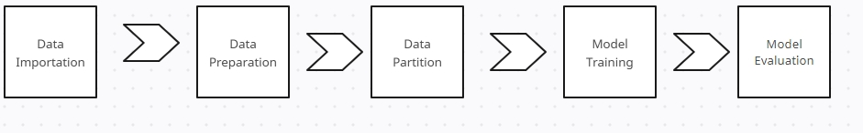

**Fig 4.1 Implementation Architecture**

**4.3 Software Testing (Evaluating the System)**

To make sure the high-traffic system with user preference prediction performs as planned, manages load effectively, and satisfies both functional and non-functional objectives, system testing is essential. A methodical approach to the many kinds of system testing that ought to be carried out—functional, performance, security, and usability tests—is provided below.

### ****4.3.1 Data Integrity and Accuracy Testing****

#### ****Data Validation Testing****

1. **Objective**: Ensure that user data (e.g., interactions, preferences) is accurately collected and stored.
2. **Tests**:
   1. Validate that data entered by users is correctly captured and stored in the database.
   2. Ensure that machine learning models receive the correct input data for training and prediction.

#### ****4.3.2 Model Accuracy Testing****

1. **Objective**: Verify that the machine learning model is making accurate predictions.
2. **Tests**:
   1. Compare model predictions with ground truth data to evaluate accuracy, precision, recall, and F1 score.
   2. Test different sets of features and algorithms to improve model performance.

**4.4 System Requirements**

**4.4.1 Software Requirements**

1. Operating System: Windows 10/11, macOS or Linux
2. Programming Language: R
3. Web Framework for deployment: Shiny, Docker for R, Plumber, etc

**4.4.2 Hardware Requirements**

1. Processor: Dual-Core CPU (e.g., Intel Core i3, AMD Ryzen 3)
2. RAM: 8 GB
3. Storage: 256 GB SSD (to handle fast access to data and models)
4. Graphics Card: Integrated GPU (if not using deep learning models)
5. Internet Connection: Required for accessing real-time data, APIs, etc.

**4.5 Deployment Procedure**

Deploying an application or model built in **R** involves multiple steps, from preparing the application or model, selecting the deployment method, and finally making it available to end users. There are several frameworks and techniques to do this. I am just going to enumerate just two and their methods:

Before deployment, ensure that your R application or model is fully functional and optimized for performance. This involves:

1. **Testing**: Ensure your app works as expected locally. For Shiny apps, test interactive elements; for machine learning models, check accuracy and performance.
2. **Dependencies**: List and install all the required R packages. The rent package can manage dependencies and create a reproducible environment.
   1. **Discussion of Results**
      1. **Identifying the Cause of Traffic**

First off, there was thorough research on the causes of traffic and how it affects users, preferences. It was discovered that this traffic is caused by data created due to the high number of users over a system (Khan et al, 2023).

* + 1. **Developing the Predictive Model**

To develop the predictive model, hybrid learning; an unsupervised machine learning technique was used. Hybrid Learning incorporates both collaborative and content-based filtering in training the model. This Machine learning technique was used to implement a recommender system that can help predict users’ preferences in a high-traffic environment.

* + 1. **Implementing the Model**

Implementing the model, first the dataset was imported into R studio, then it was cleaned, processed and validated before the model was trained and tested.

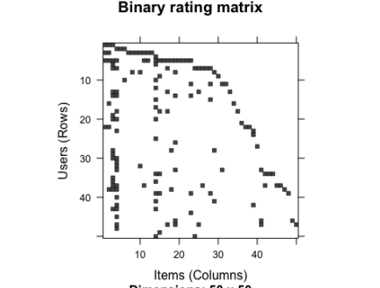

**Fig 4.2 Binary rating matrix**

The image above, shows the data sparsity in the dataset after coercing the matrix into binary rating matrix.

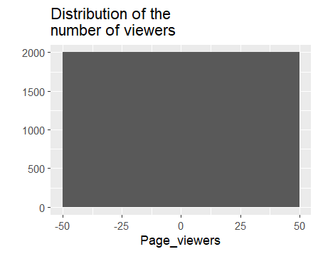

**Fig 4.3**

This chart shows the distribution of users(viewers) and their interaction with the system.

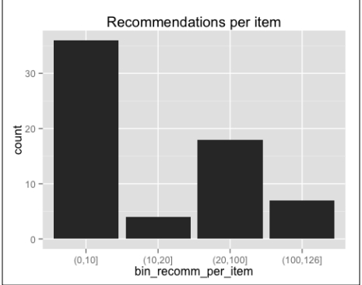

**Fig 4.4 Recommendation Bar Chart**

The chart above shows that most of the items have been recommended 10 times or fewer, and a few of them have more than 100 recommendations. The distribution has a long tail.

* + 1. **Test and Evaluate**

The following are the steps to evaluate and optimize the model:

1. Build a function that evaluates the model given a parameter configuration: sets up cross validation using k-fold.
2. Use the function to test different parameter configurations and pick the best one

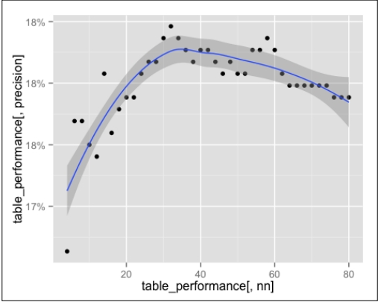

**Fig 4.5 Line Chart of the Performance of the Model.**

The line chart above shows the percentage of successful recommendations. The smoothed line grows until the global maximum of nn=35, then slowly decreases.

The user preference prediction system delivers precise, tailored recommendations that improve user engagement and produce commercial results, even in a high-traffic setting. Strong scalability, security, and adherence to data protection laws are all displayed by the system. Overall, the results show that the system effectively achieves its objectives of offering a customized user experience, even under high demand, even though there are several areas for development, especially about new users and resource optimization.

**CHAPTER FIVE**

**SUMMARY AND CONCLUSION**

**5.1 Summary**

This system uses R-based deployment frameworks and machine learning models to deliver user-specific recommendations that are efficient, accurate, and tailored to their needs. This project's overarching objectives are to improve user experiences, maximize decision-making, and help predict user preferences in a high-traffic environment. High-traffic environments often present users with an overwhelming number of options, making it difficult for users to find suitable items. Without tailored recommendations, users often face inefficient and time-consuming processes. The challenge lies in building a system that can handle a variety of user preferences, market trends, and property attributes while delivering recommendations that improve conversion rates and user satisfaction. The project aims to develop a users’ preferences prediction model system that can predict and suggest relevant items to users based on their preferences, engagements, and location, as well as recommend similar and preferred items based on their previous interactions or profiles. The system must be scalable, efficient, and secure, offering a seamless user experience on both the front end and back end.

The system starts by gathering information from a variety of sources, including user profiles, movie databases, and e-commerce platforms. For use in the recommendation algorithms, information on user preferences (e.g., interaction, location preferences), historical user behaviors (e.g., previous clicks, views), and item features (e.g., location, price, likes, ratings) is processed and cleaned. Machine learning algorithms are at the heart of the system and are used to generate customized recommendations. Generally, two kinds of algorithms are employed: Collaborative Filtering and Content-Based Filtering. The system is built on R. After deploying the recommendation system, it is evaluated based on multiple metrics: performance metrics, user engagement, response time, and business metrics.

**5.2 Conclussion**

This system addresses the challenges of item search by offering a highly personalized, scalable, and efficient solution. Through the use of machine learning algorithms, R-based deployment frameworks, and a focus on user engagement, the system significantly enhances the experience for users, contributing to the overall efficiency and success of high-traffic environments.

**5.3 Recommendations**

As the system continues to evolve, there are several areas where improvements can be made to enhance both the **technical capabilities** and **user experience**. The following recommendations are aimed at optimizing the system's performance, scalability, personalization, and business impact.

While the current system utilizes collaborative filtering and BPR for recommendations, there are opportunities to further improve personalization through more sophisticated machine learning techniques. As user engagement grows, it’s essential that the system can scale efficiently and maintain high performance, improving the variety and quality of the data used in the recommendation process can significantly enhance the system’s output, design, and user experience (UX) of the platform play a crucial role in engagement. Enhancing the interface will make the system more intuitive and accessible for users, as the system handles sensitive user information, security and data privacy are critical. Strengthening these areas will build user trust and protect against data breaches, Providing users with advanced tools can help them better manage their properties and streamline tenant acquisition and incorporating user feedback into the recommendation system will ensure that it continues to evolve in line with user needs and preferences.

**5.4 Suggestion for Further Studies**

While the system performs well under current conditions, future improvements can include:

1. **Advanced Personalization**: By incorporating more granular user preferences, such as lifestyle preferences or future item requirements, the recommendation system can provide even more tailored suggestions.
2. **Machine Learning Enhancements**: Incorporating more advanced models like deep learning could further improve the system’s ability to capture complex patterns in user behavior.
3. **Data Security**: As with any system handling personal information, ensuring robust security protocols for tenant and landlord data is essential. Regular updates to data handling policies and encryption methods will be crucial.

**REFERENCES**

1. Aggarwal, C. C. (2016). *Recommender Systems: The Textbook.* Springer.
2. Bansal, T., Belanger, D., & McCallum, A. (2015). *Ask the GRU: Multi-Task Learning for Deep Text Recommendations.* Proceedings of the ACM SIGKDD International Conference on Knowledge Discovery and Data Mining, 1079-1088.
3. Becker, G. S. (1976). *The Economic Approach to Human Behavior.* University of Chicago Press.
4. Bell, R. M., Koren, Y., & Volinsky, C. (2008). *Modeling relationships at multiple scales to improve accuracy of large recommender systems.* Proceedings of the 14th ACM SIGKDD International Conference on Knowledge Discovery and Data Mining, 95-104.
5. Bobadilla, J., Ortega, F., Hernando, A., & Gutierrez, A. (2013). *Recommender systems survey.* *Knowledge-Based Systems*, 46, 109-132.
6. Fishburn, P. C. (1970). *Utility Theory for Decision Making.* Wiley.
7. Gomez-Uribe, C. A., & Hunt, N. (2015). *The Netflix Recommender System: Algorithms, Business Value, and Innovation.* *ACM Transactions on Management Information Systems (TMIS)*, 6(4), 1-19.
8. Kahneman, D., & Tversky, A. (1979). *Prospect Theory: An Analysis of Decision under Risk.* *Econometrica*, 47(2), 263-291.
9. Koren, Y., Bell, R., & Volinsky, C. (2009). *Matrix factorization techniques for recommender systems.* *Computer*, 42(8), 30-37.
10. Lops, P., Gemmis, M. D., & Semeraro, G. (2011). *Content-based recommender systems: State of the art and trends.* In *Recommender Systems Handbook* (pp. 73-105). Springer.
11. Lü, L., Medo, M., Yeung, C. H., Zhang, Y. C., Zhang, Z. K., & Zhou, T. (2012). *Recommender systems.* *Physics Reports*, 519(1), 1-49.
12. Pazzani, M. J., & Billsus, D. (2007). *Content-based recommendation systems.* In *The Adaptive Web* (pp. 325-341). Springer.
13. Ricci, F., Rokach, L., & Shapira, B. (2011). *Introduction to Recommender Systems Handbook.* In *Recommender Systems Handbook* (pp. 1-35). Springer.
14. Sarwar, B., Karypis, G., Konstan, J., & Riedl, J. (2001). *Item-based collaborative filtering recommendation algorithms.* Proceedings of the 10th International Conference on World Wide Web, 285-295.
15. Schafer, J. B., Frankowski, D., Herlocker, J., & Sen, S. (2007). *Collaborative filtering recommender systems.* In *The Adaptive Web* (pp. 291-324). Springer.
16. Shani, G., & Gunawardana, A. (2011). *Evaluating recommendation systems.* In *Recommender Systems Handbook* (pp. 257-297). Springer.
17. Xia, Y., Liu, C., & Wang, H. (2015). *A survey of recommendation systems.* *Management Science and Engineering*, 9(1), 39-51.
18. Zhang, S., Yao, L., Sun, A., & Tay, Y. (2019). *Deep learning-based recommender system: A survey and new perspectives.* *ACM Computing Surveys (CSUR)*, 52(1), 1-38.
19. Zhao, Y., Xu, Y., Chen, Z., & Zha, H. (2017). *Deep reinforcement learning for page-wise recommendation systems.* Proceedings of the 26th International Conference on World Wide Web, 2291-2299.
20. Zheng, L., Noroozi, V., & Yu, P. S. (2017). *Joint deep modeling of users and items using reviews for recommendation.* Proceedings of the 10th ACM International Conference on Web Search and Data Mining, 425-434.